(Attention Specifiers, all areas in red require you to make selection based on requirements of the project before issuing specification. Please refer to the appropriate product data page when making your selection. All data pages are available at https://acousticalsolutions.com/)

RECOMMENDED SPECIFICATION FOR
ALPHASORB® ACOUSTIC FOAM WAVE CEILING CLOUD

PART 1 GENERAL

1.01 SUMMARY
- Section includes:
- AlphaSorb® Acoustic Foam Wave Ceiling Clouds
- Furnish and install all clouds and associated installation accessories as shown on the drawings, and specified herein, or as required to complete the work.
- Related Documents: This section applies to drawings and general provisions of the subcontract. Review these documents for coordination with additional requirements and information that apply to work under this section. Cross-reference approved supplementary manufacturers’ wave clouds and required installation accessories including, but not limited to construction-grade adhesive, corkscrews, eye bolt hangers, hanger wire, c-channel, etc., where applicable.

1.02 REFERENCES
- ASTM E84 - Standard Test Method for Surface Burning Characteristics of Building Materials.
- B. ASTM E1264 - Standard Classification for Acoustical Ceiling Products.
- C. ASTM C423-17 - Standard Test Method for Sound Absorption and Sound Absorption Coefficients by the Reverberation Room Method.

1.03 SYSTEM DESCRIPTION
- Performance Requirements
- Provide sound-absorptive wave ceiling clouds designed and tested to provide a Class A flame spread rating when tested in accordance with ASTM E84, unless otherwise specified.
- Flamespread: 25 maximum.
- Smoke Developed: 50 maximum.
- Provide sound absorptive wave ceiling clouds which have been manufactured, fabricated, and installed to provide an Apparent Noise Reduction Coefficient (Apparent NRC) rating as follows, in accordance with ASTM C423-17a:
- Noise Reduction Coefficient 0.90 Type A Mounting mounted with construction adhesive or equivalent.
- Apparent Noise Reduction Coefficient 1.35 Type J Mounting suspended from the structural ceiling as clouds.
- Provide sound absorptive waves which have been manufactured, fabricated and installed to provide the following total absorption over the following frequencies in Sabins:
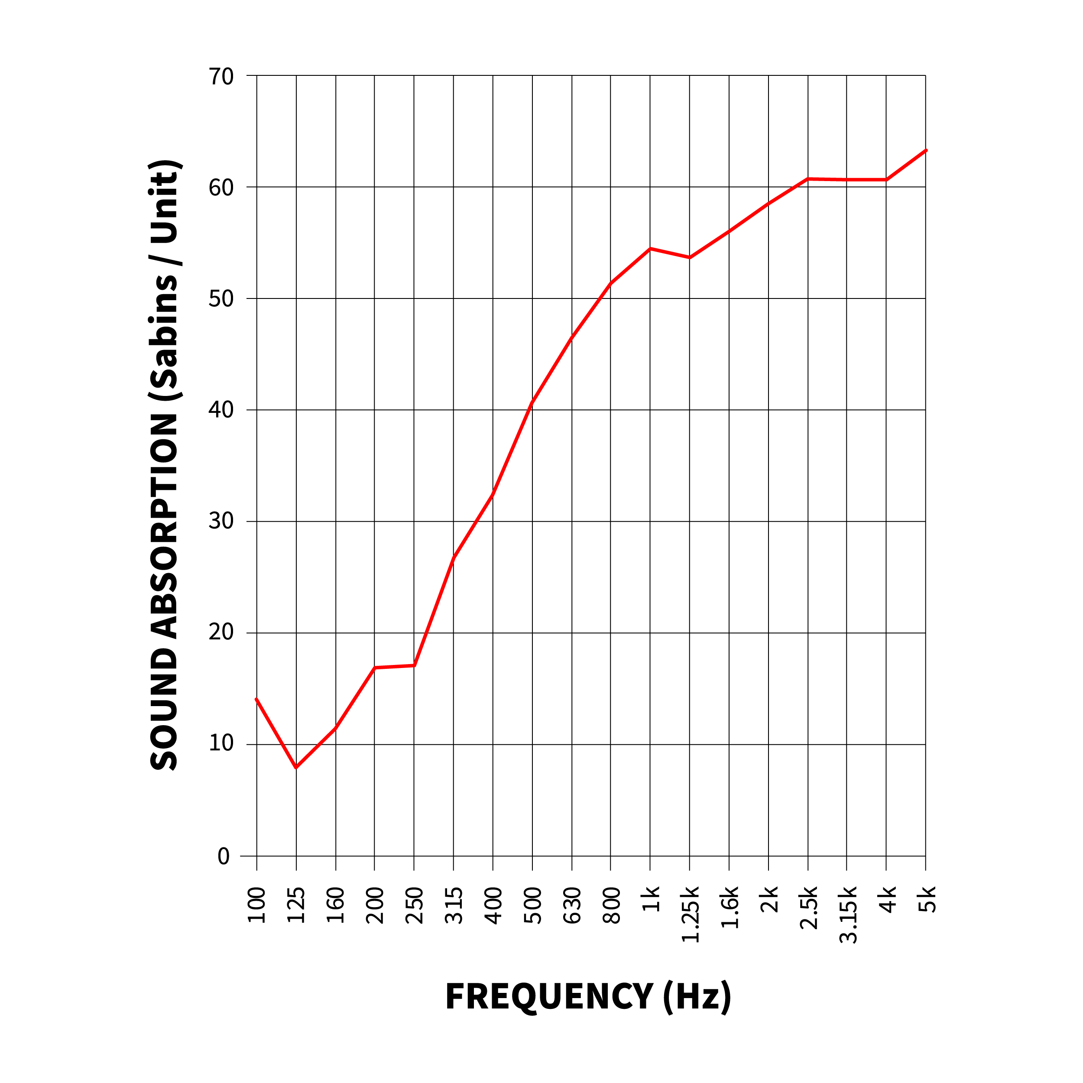

1.04 SUBMITTALS
- Product Data: Manufacturer’s technical data for wave ceiling clouds.
- Selection and Verification Samples: One (1) 6 inch by 12 inch sample for verification.
- Shop Drawings: Layout and details of wave ceiling clouds. Show locations of items which are to be coordinated with, or supported by the structural ceilings.
- Closeout Submittals:
- Operating and Maintenance Manual, including cleaning and maintenance instructions.
- Extra Material for Owner’s stock.
- Safety Data Sheets (SDS).
- Manufacturer’s Certificates: Certify products meet or exceed specified requirements.

1.05 QUALITY ASSURANCE
Note to Specifier: Paragraph below should list obligations for compliance with specific
code requirements particular to this section. General statements to comply with a
specific code are typically addressed in Conditions of the Contract and Division 1
Regulatory Requirements Section. Repetitive statements should be avoided.
- Minimum 5 years of experience in manufacturing acoustical products similar in complexity of the types specified herein.
- Single-Source Responsibility: ACOUSTICAL SOLUTIONS to provide wave ceiling clouds (only).
- Installer Qualifications: Acceptable to the manufacturer of the acoustical products being installed. Utilize an installer having demonstrated experience on projects of similar size and complexity.
- Mock-Up: Provide a mock-up for evaluation of installed appearance.
- Install acoustical products in areas designated by proper authority.
- Do not proceed with remaining work until proper authority approves workmanship and appearance.
- Approved mock-up may remain as part of the work.
- Surface Burning Characteristics
- Tested in accordance to ASTM E84
- Fire Class A
- Flame Spread Index <25
- Smoke Developed Index <50

1.06 DELIVERY, STORAGE AND HANDLING
- Delivery: Deliver material in the manufacturer’s original, unopened, undamaged containers with identification labels intact.
- Provide labels indicating ACOUSTICAL SOLUTIONS brand name, style, size, thickness and diameter, where applicable.
- Storage and Protection: Comply with manufacturer’s recommendations. Store acoustical product indoors and protected from exposure to harmful environmental conditions and at temperature and humidity conditions recommended by the manufacturer.

1.07 PROJECT CONDITIONS
- Environmental Limitations
- Install wave ceiling clouds only in conditions that are within the manufacturer’s published limits for temperature and humidity.
- Areas receiving wave ceiling clouds should be free of construction debris and dust.
- Mechanical, sprinkler and electrical trades shall have completed their work above the ceiling structure and within structural walls prior to commencement of product installation.

1.09 MAINTENANCE
- Extra Materials: Provide a minimum of 1 box or 2%, whichever is larger, of additional materials if required for use by owner or the building maintenance and repair.
- Provide new unopened cartons of extra materials, packaged with protective covering for storage and identified with appropriate labels.

1.09 WARRANTY
- One-year limited warranty from invoice date for defects in workmanship or material.
- Warranty excludes normal wear and tear, misuse, improper installation, and external damage.
- Extended warranties are available for designated products.

PART 2 PRODUCTS

2.01 MANUFACTURER
- ACOUSTICAL SOLUTIONS
- 3017 Vernon Road, Richmond, VA 23228 | PH: 800-782-5742 | acousticalsolutions.com
- Requests for substitutions will be considered in accordance with provisions of Section 01 60 00 - Product Requirements

2.02 MATERIALS
- AlphaSorb® Acoustic Foam Wave Ceiling Clouds: wave ceiling clouds are manufactured from 100% open-cell melamine foam with the following characteristics:
- Fire Resistance: ASTM E84, Class A
- Apparent NRC 1.35 per ASTM C423 Type J mounting as clouds
- Foam Density: Light Grey 0.56 lbs./ft³ +/- 0.09 lbs./ft³; White 0.47lbs./ft³ +/- .13lbs./ft³
- Service Temperature: -40˚F to 350˚F
- Size: Nominal: 12 inches x 48 inches, 18 inches x 48 inches, 24 inches x 48 inches, 48 inches x 48inches, 48 inches x 96 inches. Custom sizes available.
- Manufacturers Custom Coating/Colors: Available upon request.
- Product Substitutions: Not permitted.
- Accessories
- Construction adhesive, hanger wire and mounts, eye bolts, c-channel and associated framing to be supplied by others.
- Corkscrews to be supplied by ACOUSTICAL SOLUTIONS

PART 3 EXECUTION

3.01 EXAMINATION
- Examine wave installation, with installer present, for compliance with requirements specified in this and other applicable Sections affecting wave installation and with requirements for installation tolerances and other conditions affecting waves from ceilings.
- Verify wave layout conditions, which will adversely affect installation.
- If layout or substrate preparation is the responsibility of another installer, notify Architect of unsatisfactory preparation before proceeding.
- Verify wet work such as plastering and concrete is complete and dry. Verify building is enclosed and under standard occupancy conditions prior to start of installation.
- Commencement of installation constitutes Installer’s acceptance of substrate conditions.

INSTALLATION
- Do not begin installation until materials sufficient to complete an entire room are received and prepared for installation.
- Fit wave ceiling clouds in place, free from damaged edges or other defects detrimental to appearance and function.
- Symmetrically locate ceiling cloud layout, as desired, in each space. Coordinate work with other trades so that lighting fixtures, HVAC and other ceiling mounted fixtures work with hanging cloud layout.
- Install materials in accordance with manufacturer’s printed instructions and to comply with governing regulations, fire resistance rating requirements as indicated and industry standards applicable to the work.
- Install units after ceiling work is complete.
- Hang clouds in uniform plane, where required, and free from twist, warp, and dents.

3.03 CLEANING
- Clean exposed surfaces of wave ceiling clouds, and any installation accessories to comply with manufacturer’s instructions for cleaning.
- Clean adjacent surfaces and remove unused materials and debris from site.
- Touch up any minor finish damage.
- Remove and replace work that cannot be successfully cleaned and repaired to permanently eliminate evidence of damage.

3.04 PROTECTION
- Protect installed products until completion of project.
- Remove and reinstall improperly installed material.

END OF SECTION

